TASK 3: Protein Structure Prediction

1. Objective
To select one protein sequence from UniProt, predict its 3D structure using AlphaFold DB, and visualise the structure using PyMOL, including an analysis of backbone dihedral (phi/psi) angles.

2. Protein Selected
Protein: Hemoglobin subunit beta (HBB). UniProt accession P68871, entry name HBB_HUMAN, organism Homo sapiens (Human), 147 amino acids, reviewed (Swiss-Prot) entry with UniProtKB annotation score of 5/5. This protein was selected for continuity with the Task 2 alignment, since HBB_HUMAN was one of the five sequences used in the MSA, and because it is a well-characterised, high-confidence target with an existing very-high-quality AlphaFold model, making it ideal for demonstrating structure prediction and visualisation. Its biological function is oxygen transport from the lungs to peripheral tissues as part of the haemoglobin tetramer.

3. Method
- The target sequence and accession (P68871, HBB_HUMAN) were retrieved from UniProtKB (https://www.uniprot.org/uniprotkb/P68871/entry).
- Rather than submitting a new modelling job, the existing predicted structure was looked up directly on AlphaFold DB (https://alphafold.ebi.ac.uk/entry/P68871), which hosts a pre-computed AlphaFold Monomer v2.0 model for this UniProt entry (model AF-P68871-F1-v6).
- The predicted structure file (AF-P68871-F1-model_v6.pdb) was downloaded from the AlphaFold DB entry page via the "Download files" option.
- The PDB file was opened in PyMOL and rendered as a cartoon/ribbon view coloured green to highlight secondary structure.
- A backbone dihedral (phi/psi) angle plot was generated using a PyMOL "Dynamic Angle Plotting" tool to assess the distribution of torsion angles as a structural quality check, analogous to a Ramachandran plot.
Model confidence and background information (average pLDDT, pLDDT distribution, source organism) were confirmed from the AlphaFold DB summary page, and the AlphaFold header metadata was checked in the PyMOL command log.

4. Structure Images
The figures below show the AlphaFold DB entry, the model loaded and rendered in PyMOL, the UniProt entry for HBB_HUMAN, and the backbone dihedral angle plot.
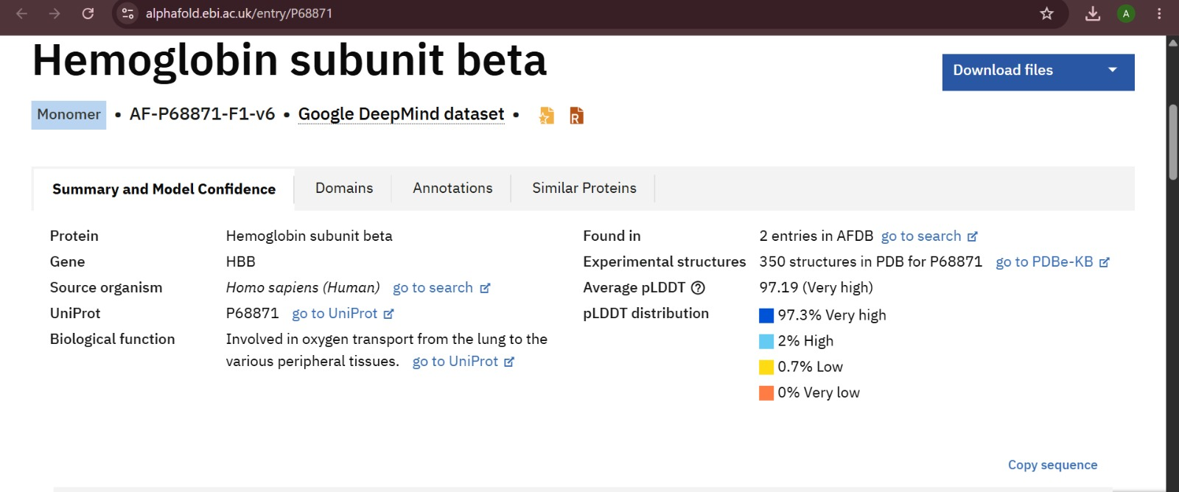
Figure 3: AlphaFold DB entry for Hemoglobin subunit beta (P68871), showing model AF-P68871-F1-v6 and an average pLDDT of 97.19 ("Very high").

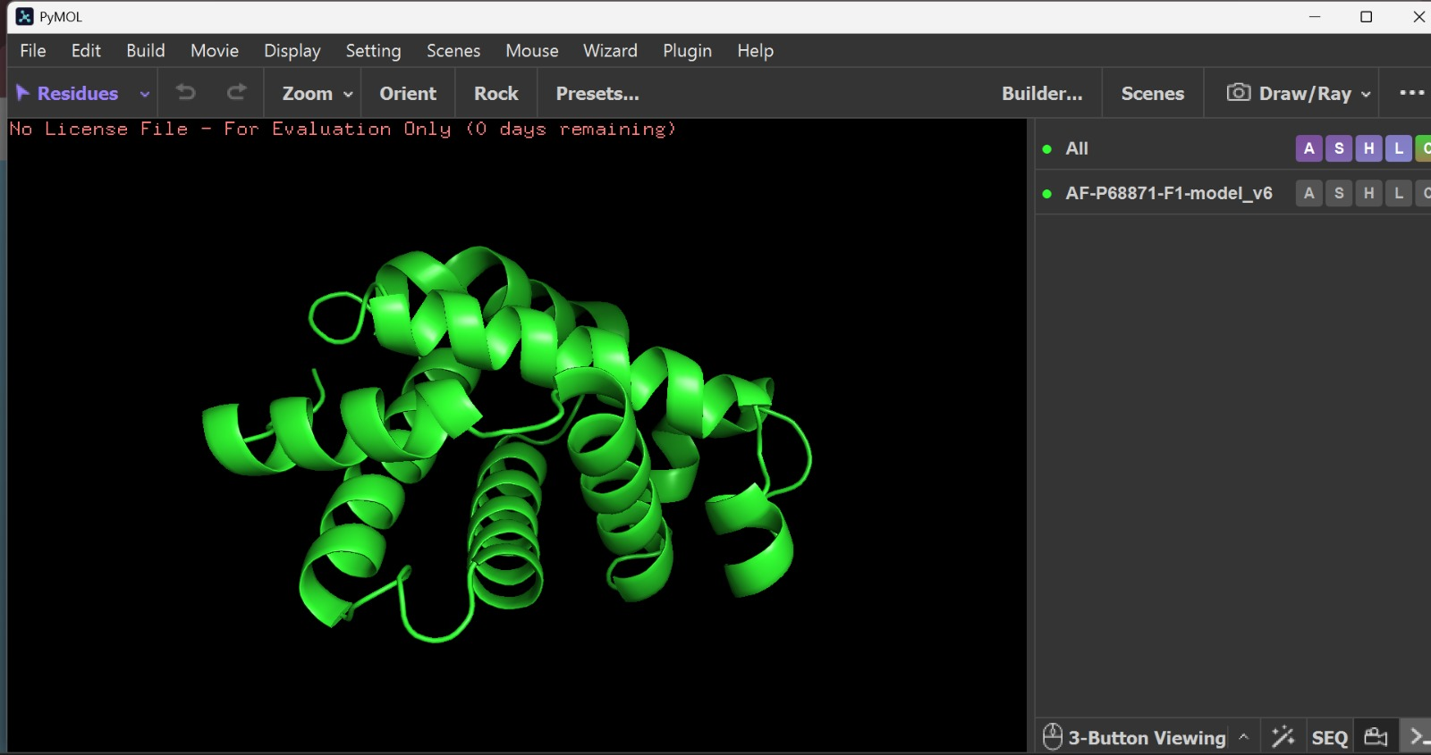
Figure 4: The AF-P68871-F1 model loaded in PyMOL and displayed as a cartoon/ribbon view.
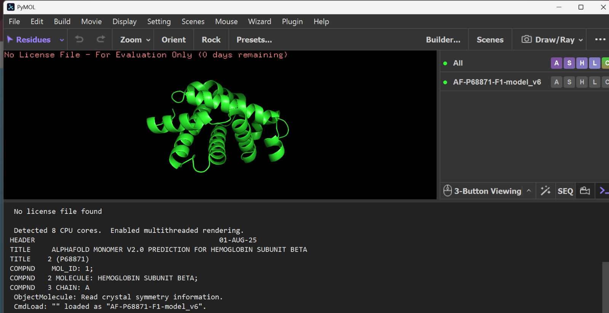
Figure 5: PyMOL command log confirming the loaded file is the AlphaFold Monomer v2.0 prediction for Hemoglobin subunit beta (P68871), chain A.

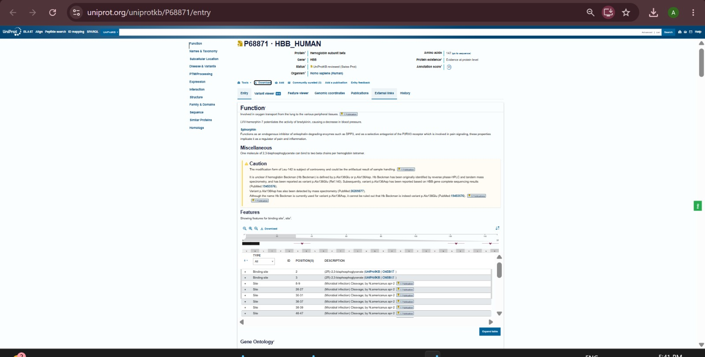
Figure 6: UniProt entry for P68871 (HBB_HUMAN) showing gene HBB, 147 amino acids, and functional annotation (oxygen transport, 2,3-BPG binding sites).
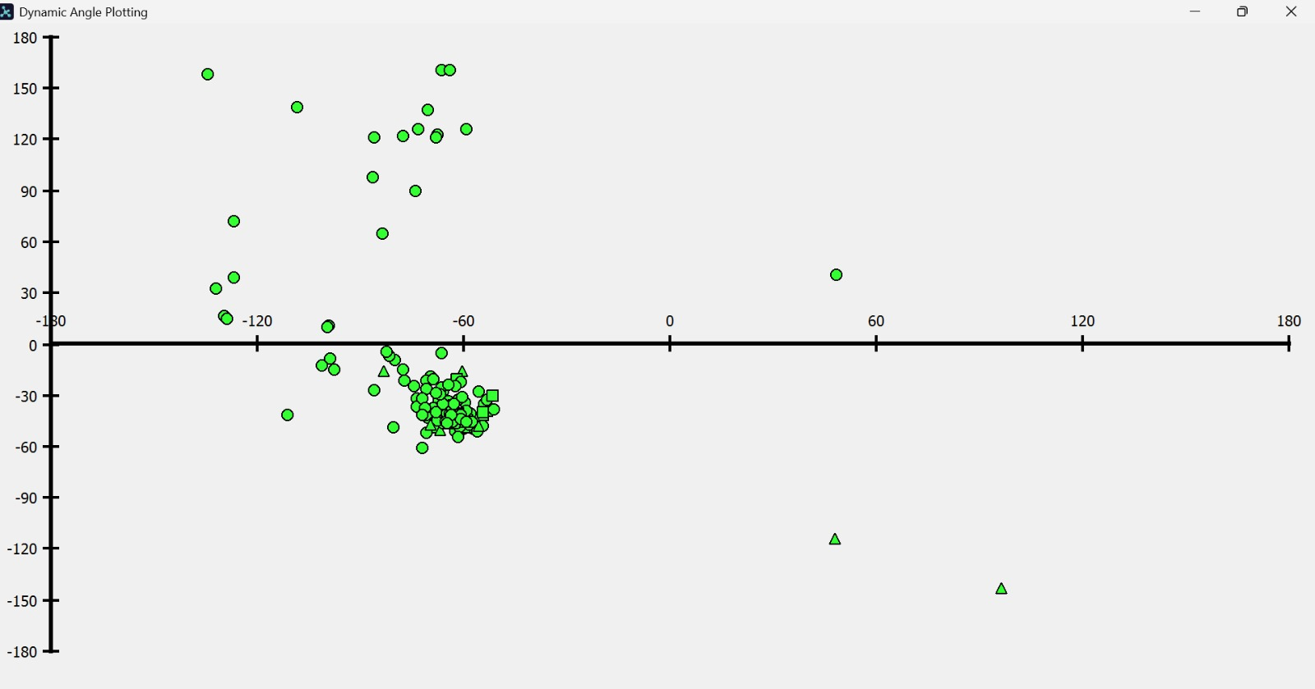
Figure 7: Backbone dihedral (phi/psi) angle plot for the modelled residues. The large cluster of points near (phi ≈ -60°, psi ≈ -45°) corresponds to the right-handed alpha-helical region of the Ramachandran plot, consistent with the predominantly helical globin fold; a small number of outlying points correspond to loop and turn residues.

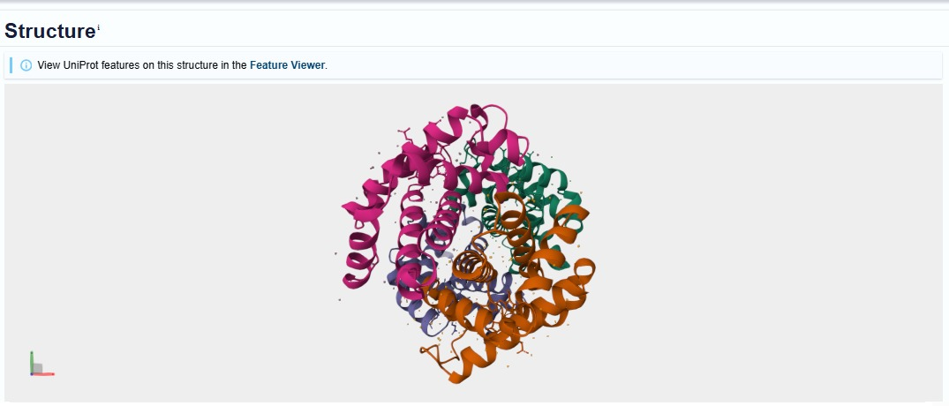
Figure 8: Reference quaternary structure of human haemoglobin (experimentally determined, related PDB structure) shown on the UniProt "Structure" tab, with each of the four globin chains coloured separately, for comparison with the single AlphaFold-predicted beta subunit above.

5. Structural Features — Short Report
The predicted structure of Hemoglobin subunit beta (P68871) is almost entirely alpha-helical, with no beta-sheet content, consistent with the classical "globin fold": a compact bundle of connected helices (conventionally labelled A–H in globins) linked by short loops, wrapping around a central cavity that in the full, ligand-bound protein accommodates the heme prosthetic group. Because AlphaFold predicts only the protein backbone from sequence and does not model bound cofactors, the heme group itself is not present in this structure file, but the shape of the predicted helical bundle is consistent with the known heme-binding pocket seen in experimental haemoglobin structures. The backbone dihedral angle plot supports this assignment: the great majority of phi/psi points fall in the tight cluster around phi ≈ -60°, psi ≈ -45°, the classic right-handed alpha-helix region of the Ramachandran space, with only a handful of points scattered elsewhere corresponding to the short connecting loops and turns between helices; no points fall in the beta-sheet region (phi ≈ -120°, psi ≈ +120°), confirming the absence of beta-strand structure. Model confidence is very high: the AlphaFold DB entry reports an average pLDDT of 97.19, with 97.3% of residues scored "Very high" confidence, 2% "High", and only 0.7% "Low" and 0% "Very low" — indicating that essentially the entire predicted backbone, including the core helical bundle, can be trusted at near-experimental accuracy. In the full haemoglobin tetramer (of which this beta subunit is one of four chains), two conserved histidine residues within this helical fold — the proximal and distal histidines identified in the Task 2 alignment — are responsible for coordinating and stabilising the heme-bound oxygen molecule.

6. Conclusion
Using the AlphaFold DB prediction for human Hemoglobin subunit beta (P68871, HBB_HUMAN), this task produced a high-confidence 3D structural model (average pLDDT 97.19) that was visualised in PyMOL and further examined through a backbone dihedral angle plot. The model confirms the expected all-alpha globin fold, with backbone torsion angles concentrated almost exclusively in the alpha-helical region of phi/psi space and no evidence of beta-sheet structure. Taken together with the sequence conservation observed for this protein family in Task 2 — particularly around the heme-coordinating histidines — the predicted structure is consistent with a protein whose fold is tightly constrained by its role in oxygen binding and transport, reinforcing the link between conserved sequence, conserved structure, and conserved function across the beta-globin family.

